Main Title of Long Paper: [Calibri 18 bold]
Subtitle of long paper [Calibri 16]

Double-blind review process

Do not include authors in the body text at this time

ABSTRACT: This abstract should be a maximum of 200 words in a single paragraph. This “Abstract” should also be input in the ConfTool system under the “Abstract” part in the “Contribution Details”. Read these notes carefully all the way through and follow them as precisely as possible. This document explains how to prepare a paper for submission to the PLEA 2020 Conference. It also includes the instruction for submission and some other information. This MS-Word document should be used as a template. Text in red gives some overview on layout and should absolutely be deleted in your paper version. [Calibri 9 italic, justified]
KEYWORDS: Energy, Comfort [Up to 5, Calibri 9 italic, followed by 2 blank lines]

1. INTRODUCTION [HEADING-Calibri 10pt bold capitals]
[Main Text: Calibri 10pt] These instructions apply for 6-page long papers. Your long paper has to be submitted electronically by 27th of March 2020. This is an absolute deadline. Earlier would be welcomed! Please note that no guarantees can be given for oral presentation of a paper until the receipt of the full version of long paper and its final approval by the Scientific Committee. All approved long papers will be published on a USB-memory stick handed out with the conference documents at PLEA 2020. Authors are fully responsible for their papers, which should not have been published elsewhere. They must have taken the necessary steps to obtain permission for using any material that might be protected by copyright.
The publication of long paper requires your registration at the PLEA 2020 Conference in A Coruña. For each accepted paper, at least one presenting author has to register for conference participation, otherwise the contribution will not be considered in the conference proceedings.

2. PREPARING THE MANUSCRIPT
With A4 paper size (210 × 297 mm), illustrations and references included, long paper should be limited to 6 pages. Please prepare your paper according to these instructions as the reviewer will be strict in enforcing them in this round. If you fail to follow the instructions in this template, the contribution will not be accepted to be published in the proceedings.
This template is a version of the previous extended abstract template. You may load it with the previous content or you may modify your old file to match this one. Use this document in preparation of your paper and follow these guidelines. Keep the text within the margins shown in this example. Leave one empty line before each section or subsection. There should be no empty line after the title of the subsections, only an indentation to indicate the beginning of each paragraph. The text should be justified with single line spacing. The section headings should be typed in capital letters in bold and be numbered. Subsections should be typed in upper and lower case, and numbered in bold.

2.1 Tracks and title [Subheading: Calibri 10pt bold, upper and lower case]
Submission should be present new, original research that focuses on ONE of the five tracks:
- Sustainable Buildings
- Resources
- Resilient and Extreme Design
- Sustainable Communities
- Analysis and Methods
- Education and Training
The title should be informative and concise. Avoid using acronyms in the title. Precede the body of your paper with an abstract of 100-200 words, giving a brief account of the most relevant aspects of your paper, then with up to 5 keywords that best apply to your paper.

2.2 Citation and references
References should not appear as footnotes but should be gathered together at the end of the text. References should be numbered and cited like, [1], [2-3], [1,4], etc. Numbered references matches previous PLEA proceedings.
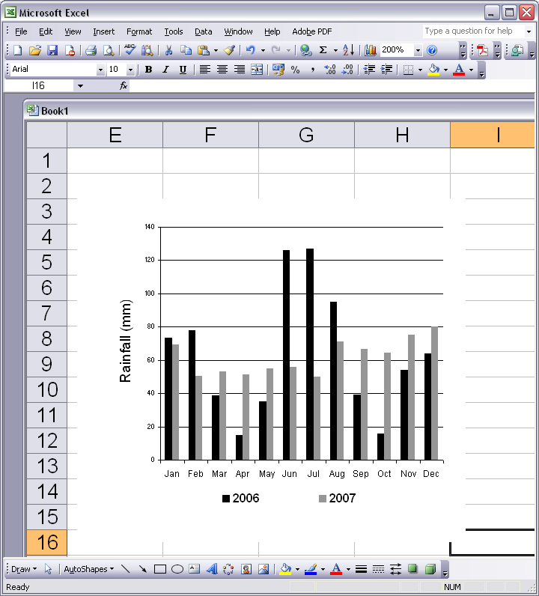
Figure 1: Clear line drawings are essential. [Calibri 9 italic]

2.3 Figures and tables
Drawings and graphs should not exceed 50% of the entire paper content and should be located close to their corresponding citation. They may reside within a column or span both columns. Figures and photographs must carry numbers in the text (Fig. 1) and a caption. Captions should be complete enough to allow appreciation of the illustration without referring to the text. Lettering of the caption should be nearly as large as the typeface used for the text. Make sure that illustrations are clear and easy to read. Tabular presentation of data is an easy way of condensing many items. Tables must also carry numbers in the text (Table 1) and caption. Images and graphics can be color, but must be legible in black and white for greyscale for printing purposes. For example, use different fill patterns or line styles/markers or contrasting shades, which can be more easily distinguished when printed (refer to Fig. 1). Please test-print your paper in black and white to ensure that the information you want to give is clearly presented.

Table 1: Sky conditions probability for clear sky (ρ_{cs}), partly overcast sky (ρ_{ps}), and fully overcast sky (ρ_{os}). [Calibri 9 italic]

Month | ρ_{cs} (%) | ρ_{ps}(%) | ρ_{os}(%)
JAN | 5.88 | 36.88 | 57.24
FEB | 6.79 | 45.65 | 47.57
MAR | 5.48 | 40.40 | 54.12
APR | 16.39 | 51.58 | 32.03
MAY | 11.18 | 45.27 | 43.55
JUN | 12.87 | 33.68 | 53.45

2.4 Equations
Equations should be centered. They are numbered as (1), (2), etc. They are referred in the main texts as “Equation (n)”. Descriptions of the equation can start from the next line. For example like the following Equation (1):
PET = 1.2T_{a} - 2.2v + 0.55 (T_{mrt} – T_{a}) (1)
where PET - Physiological Equivalent Temperature (◦C);
T_{a} - air temperature (◦C);
T_{mrt} - mean radiant temperature (◦C);
v - air speed (m/s).

3. SUBMISSION INSTRUCTION
Rename your manuscript or create a file which begins with the long paper number (id 1***, not the abstract number) and includes the submitting author’s full name (1020-Albert Einstein.doc).
Log in to the paper submission site which is at http://www.conftool.org/plea2020/ and go to “Your Submissions”. Here you can find the initial long paper which have been accepted with id 1*** (under Submission Type/Conference Track: Long Paper Submission). To complete your submission of initial long paper in this round, you should at least:
- Click on “Edit Contribution Details” to add the abstract (100-200 words).
- Click on “Upload Contribution” to submit your 6-pg long paper in both word and PDF format.
You may also add or edit the authors’ information (in Conftool) in this round if necessary, no further revisions on the contribution details are allowed in the next round. However the title of the contribution should remain the same as the submitted extended abstract. Be sure to load the correct manuscript, if you have more than one. You may not upload any other files. You may include links within your paper if you wish to provide additional materials. Note that it is possible to repeat the editing/uploading process and overwrite your file with a newer one until the submission deadline. Please only do this if absolutely necessary. The last uploaded version at the time of submission deadline will be considered for review.
We would appreciate if you can do the above on or before 27th of March 2020 (23:59 GMT) or at your earliest convenience. Thank you very much!

4. CONCLUSION
This paper showed how to prepare and upload a good paper for inclusion in the PLEA 2020 Conference. We hope to see you in A Coruña!

ACKNOWLEDGEMENTS
This section, if included, appears right after the main body of the text and is headed “Acknowledgments.” This section includes acknowledgments of help received from associates and colleagues, credits to sponsoring agencies, financial support, and permission to publish. This template has been updated from PLEA 2018 Conference.

REFERENCES
1. Igawa, N. and H. Nakamura, (2001). All Sky Model as a standard sky for the simulation of daylight environment. Building and Environment, 36: p. 763-770.
2. Kittler, R., (1985). Luminance distribution characteristics of homogeneous skies: a measurement and prediction strategy. Lighting Research and Technology, 17(4): p. 183-8.
3. Perraudeau, M., (1988). Luminance models. In National Lighting Conference. Cambridge, UK, March 27-30.
4. International Daylight Monitoring Programme, [Online], Available: http://idmp.entpe.fr/ [16 June 2008].

